Softball Hits Game Board

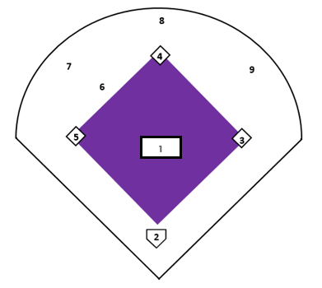

Softball Hits Score Card
Position | My Equation
1
2
3
4
5
6
7
8
9

Softball Hits Game Board
Softball Hits Score Card
Position | My Equation
1
2
3
4
5
6
7
8
9

